December 18, 2019

RE: Utah DOT Approval of A7+ Adhesives

To Whom It May Concern,

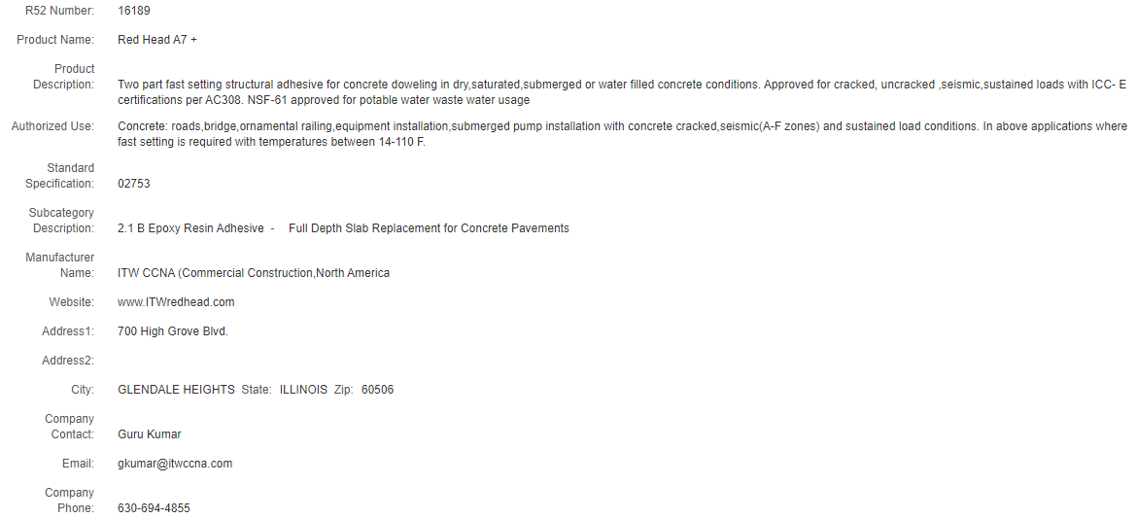

If you have any questions about our Red Head adhesives, please contact our technical support center by calling 1-800-899-7890 or emailing Technical@itwccna.com.

Sincerely,

Amy Kolczak
Codes and Approvals Manager
ITW Commercial Construction North America

