June 6, 2019

RE: New York DOT Approval of A7+ and G5+ Adhesive

To Whom It May Concern,

As of the date of this letter, A7+ and G5+ adhesives are approved for use by the New York Department of Transportation.

The above products can be found listed on the most up-to-date Approved / Qualified Product List for Concrete Anchoring Systems:
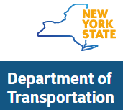

If you have any questions about our Red Head adhesives, please contact our technical support center by calling 1-800-899-7890 or emailing Technical@itwccna.com.

Sincerely,

Amy Kolczak
Codes and Approvals Manager
ITW Commercial Construction North America

